
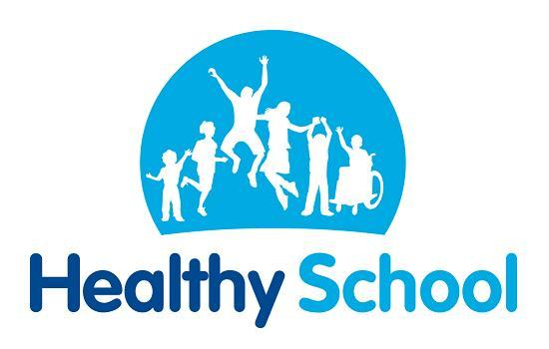


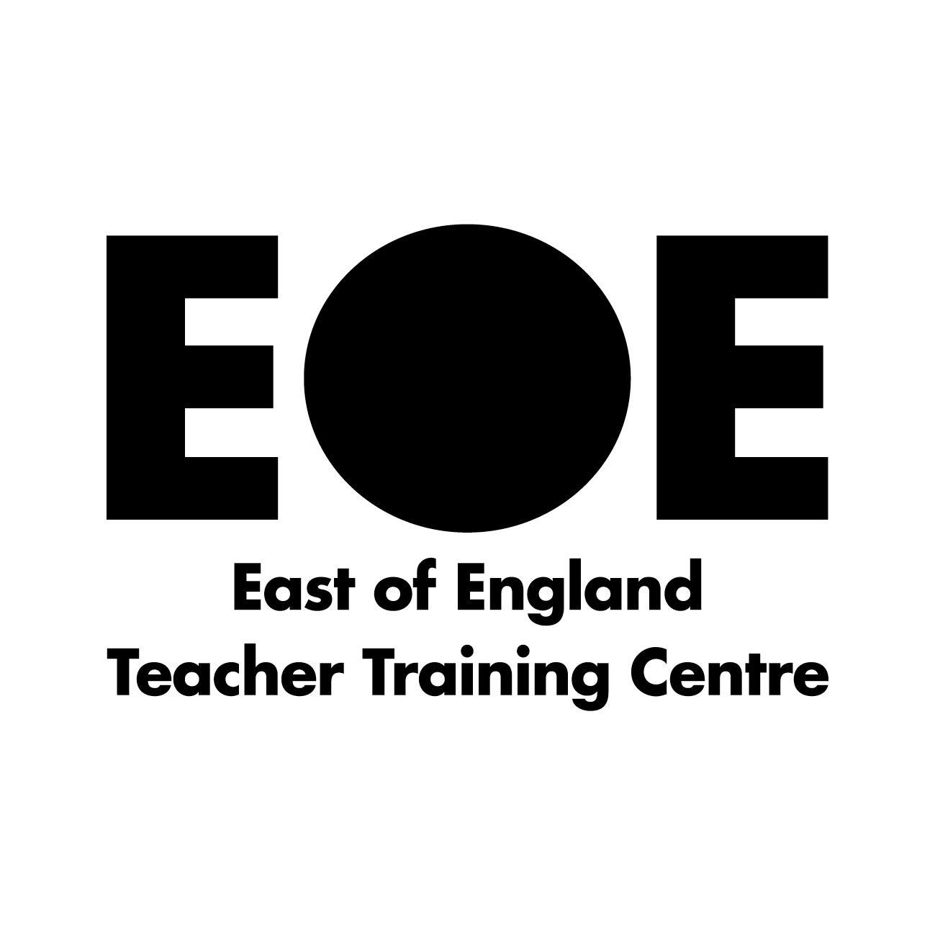


1 December 2021

Dear Parents and Carers

We are writing to you to find out your views on an exciting opportunity for our school.

Over the past year Mrs Hilton and the leadership team have been working with governors to consider future options for our school. We are really keen to make sure that the school continues to be the best it can be for our children and community we serve. It is also important that the school has a secure future and we feel that joining a wider family of schools in a Multi Academy Trust (MAT) is the best option for us.

We have looked carefully at a number of options, including starting our own MAT or joining an established MAT and after several meetings with local schools, MATs and others including the diocese we have decided that joining an established MAT is best for us. We believe that joining the Infinity Academies Trust will bring many benefits, supporting us to continue to thrive as a Church of England school.

Infinity Academies Trust is a well established MAT in which a group of primary schools work together. There are currently seven schools in the trust that are based in locations across the county including Boston and Spalding.

Joining Infinity will give our school lots of new opportunities, including enabling our staff to learn from colleagues in other schools but also share the things that we at Little Gonerby do well. As well as the positive impact on learning and teaching, joining Infinity will give us the chance to draw upon their management and administrative capacity meaning that we can be more efficient in the way we work.

Mrs Hilton and governors have not taken this decision lightly and met on several occasions with Gavin Booth, CEO of Infinity, to discuss his vision for the trust and make sure that our values align. As a Church of England school, the Diocesan Board of Education have considered our decision and have given their approval.

You can find out more information about Infinity Academies Trust by visiting its website - https://www.infinityacademies.co.uk/.

We hope that you too will find this an exciting development for our school, but know you may have questions about how this change will impact on your child and the school. We have added below a number of questions and answers that may help.

We would now like to seek your views and give you the opportunity to ask us any questions before taking the next step to formally start proceedings to join Infinity. Here is a link to a short form in which you can ask any questions or provide feedback, which we would like to be completed by 17 December 2021.

Yours sincerely

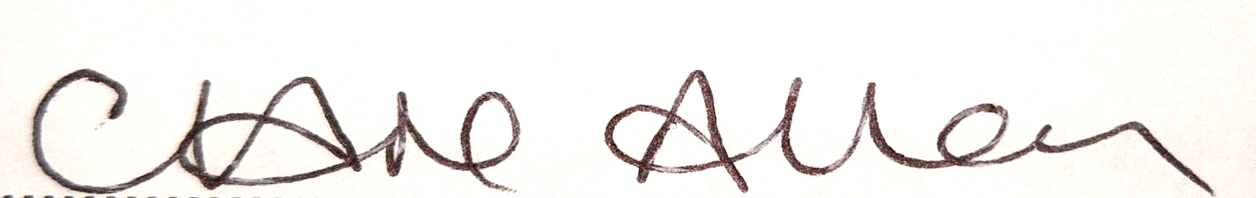

Mrs Helen Hilton Mrs Clare Allen
Head Teacher Chair of Governors

Frequently asked questions

What is a MAT?

A MAT is a multi academy trust, a group of schools who work together to improve standards and support one another for the benefit of the whole school community. The academies share in common the members and directors of the board of trustees that govern them. We will be part of the Infinity Academies Trust alongside Spilsby Primary Academy, Gipsey Bridge Academy, St Thomas’ CofE Primary Academy, Wyberton Primary Academy, Spalding Primary Academy, Pinchbeck East CE Primary Academy and St Nicholas CofE Primary Academy.

Why did you choose Infinity over other multi academy trusts?

We feel that Infinity Academies Trust share the same vision and values as Little Gonerby by putting the children at the centre of everything they do. They have a very strong offer of teaching and learning support for their schools whilst also enabling schools to retain their own unique identity, vision, leadership and curriculum. As the trust continues to grow over time there will be more schools in the Grantham area for us to work with as well.

Will there be any change to the admissions policy?
We intend to keep the current arrangements which are determined by the local authority and keep in line with any changes in the future. It is important to us that our admission arrangements remain open, transparent and inclusive.
The National Junior School has joined the Lincolnshire Anglican Academy Trust (LAAT) , a different MAT to Little Gonerby Infant School, who will be joining Infinity Academies Trust. What does this mean for my child?

The two schools have been two separate academy trusts for the past nine years and we have continued to work together over this time. We have already had very positive conversations with the new leadership at the National School, and both LAAT and Infinity trusts have made a joint commitment to work together for the benefit of all the children. The two schools will continue to work together to provide as smooth a transition as possible for our children as they move onto junior school. The National Junior School will continue to provide a place for all the children of Little Gonerby School, just as they do currently.

What changes will I notice as a parent from Little Gonerby School joining the MAT?

You should not notice any changes to the school. One of the reasons we chose Infinity Academies Trust is because we can keep our autonomy as a school including the same uniform, staff, curriculum and the same expectations. There will be benefits from a teaching perspective from sharing good practice across the MAT and support with the administrative functions of the school.

What changes will my child notice?

Again, the children should not notice any change. They will wear the same uniform, have the same teachers and follow the same curriculum using R.E.A.L. projects.

Will the uniform change once we join a MAT?

No, there will be no changes to the uniform. We will still be called Little Gonerby Church of England Infant School.

Will the school holiday dates change once we join a MAT?

No, we will maintain the dates published for this academic year and next year too. As always, we will endeavour to have the same holidays and training days as the National Junior School, although this is not always possible.

Will staff be moved around on a regular basis?

There is no intention or expectation that staff will move around between the seven schools. We do however, intend that staff will meet for shared training and moderation at various points throughout the school year to maintain highest standards of teaching and learning.

Will the governing body change?

Once we join the MAT we will have a local group of governors, including parents, staff and a church representative. The chair of the local group will attend meetings with the chairs from all the schools within the MAT as part of the board of trustees. The local group will act as our ‘academy champions’, monitoring progress, teaching and learning, curriculum and standards in different areas of the school as well as helping to maintain our church school distinctiveness. It is likely that in the new year we will be looking to recruit some parents to our local group - if being an academy champion is a role that you may be interested in, please feel free to come and have a chat to us or email our clerk mrs.gallaher@littlegonerby.co.uk for more information.

When will this all happen?

We are aiming to officially join Infinity Academies Trust from April 2022. However, the trust has already welcomed staff to a variety of network meetings and activities and key trust staff have visited Little Gonerby. We hope that parents will be able to meet the CEO of Infinity, Mr Gavin Booth, in the new year.

From the Infinity Academies Trust vision:

“Our children need and deserve to experience the highest quality learning environment within our schools, so they can develop the skills and knowledge to thrive, both academically and socially, and be prepared for a future that is full of opportunity. We will strive every day to ensure our children know they are valued, understood and supported to share their hopes and aspirations and to provide a well-rounded education that celebrates all their successes………….

………..Childhood is precious, and as teachers, support staff and leaders in schools we, alongside parents and families, are in a privileged position to ensure our children are safe, secure, ready to learn and excited by their experiences both inside and beyond the classroom. We want our children to flourish across their lives.”

